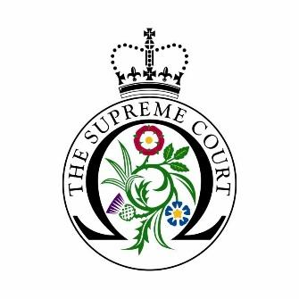

UK Supreme Court Educational Visits Booking Form

Name and address of educational institution:
Name and direct contact details of group organiser:
(if possible, please provide details that can be used on the day of your visit, in the event that we need to contact you with last minute information)
Date(s) and time(s) that you would like to visit:
(tours last 45 minutes and can be scheduled Monday-Thursday 10am, 11am, 2pm and 3pm, and Fridays 10am).
What subject(s)/course(s) are your students studying?
How many people will be in your group, including staff?
(maximum 30 people permitted due to space restrictions, including teachers/group leaders)
Are there any specific curriculum areas that you would like us to cover?
Do you have any other special requirements or questions?
Would you be happy for our caterers to send you details, by email, of options for packed lunches on your visit? (£7.50 a head)

☐ Yes ☐ No

For schools only: What is your school’s Ofsted free school meals rating?

Lower than average ☐│ Average ☐│ Higher than average ☐
For schools only: What is your school’s Ofsted rating on English as an Additional Language?
Lower than average ☐│ Average ☐│ Higher than average ☐
For schools only: Is the proportion of pupils with Special Educational Needs and Disabilities (SEND):
Lower than average ☐│ Average ☐│ Higher than average ☐
Please ensure that everyone in your group wears a face covering unless they are exempt.

Please complete this booking form and send it to enquiries@supremecourt.uk

Thank you.

